1 - 1 – Function Families – Teaching set 1
You have roughly two learning goals in all these problems:
- Make your mental picture of the families a little more accurate
- Be able to answer “why is it that way?” about different aspects of these functions.

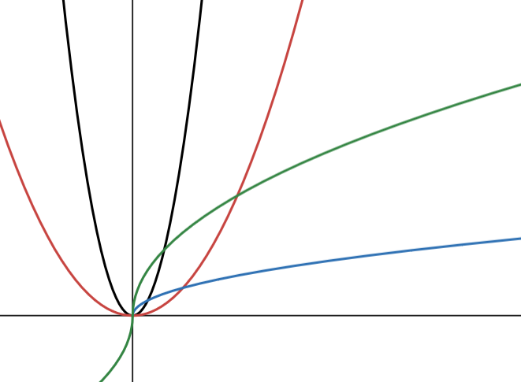
1). [C] Fix the mistakes
$$\sqrt{x}$$
$$\sqrt[3]{x}$$
$$x^{2}$$
$$x^{5}$$
Here a student tried to graph:
$$y=x^{2}$$
$$y=x^{5}$$
$$y=\sqrt{x}$$
$$y=\sqrt[3]{x}$$

But they only sort-of know the shapes and are missing some crucial details.

Re-draw these 4 functions correctly and annotate the important details the student missed or got wrong.

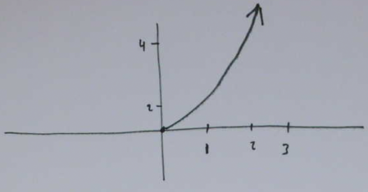
2. [C] When asked to sketch $y=2^{x}$ your partner produces this graph:
What are two specific reasons you could tell them that would convince them that this doesn’t make sense?
( Saying: “because the real answer is ____” probably won’t convince them. You need a reason why the graph doesn’t match the equation that they can check for themselves. )
3. [C] Why does $y=x^{10}$ have a “U” shape, while $y=x^{7}$ doesn’t ? Say your answers out loud, and then see if you can find a shortest, most convincing way to capture the idea.
4. [C] Why is $y=x^{10}$ below $y=x^{3}$ when x is between 0 and 1?
5. [C] Is the graph of $y=5^{x}$ ever below the graph of $y=3^{x}$ ? If not, explain why not. If so, explain where and why.

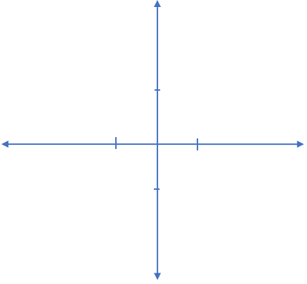
6. [P] Sketch all of the following curves on the same set of axes (similar to the one here, but make it big enough to fit everything).
Label each curve with its equation.
a. $y=x^{3}$
b. $y=x^{10}$
c. $y=\sqrt[3]{x}$
d. $y=\sqrt{x}$
e. $y=π$

- Label any points where they cross.
- Make sure it’s always clear which curves are above/below other curves

7. [C] Imainge the graphs of the even powers $y=x^{2},y=x^{10},{y=x}^{22}$ etc. What changes about them as the exponent gets larger? What do they all have in common that doesn’t change?
8. [C] Imagine the graphs of exponential functions with different bases $y=2^{x}$, $y=3^{x}$, $y={11}^{x}$ etc.
As the base increases, what changes? There’s one point that’s the same for all the graphs. Why is it on every graph $y=b^{x}$ no matter what b is (so long as $b≠0$) ?

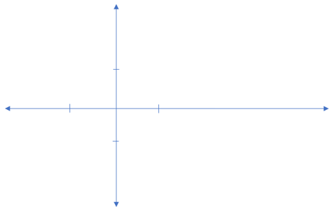
9. [P/C] On a single set of axes, sketch all of the following curves. Label points of intersection. Label each curve with its equation.
a. $y=2^{x}$
b. $y=\frac{1}{x}$
c. $y=1^{x}$
d. $y=π^{x}$

10. [C] For even powers, the “U” shape becomes more “square” as the exponent gets larger. Why?
11. [C] What’s a good explanation for why there’s no real number equal to $\sqrt{-8}$ , but there is a real number equal to $\sqrt[3]{-8}$.
Here’s an answer that doesn’t work: “because you can’t take a square root of a negative but you can take a cube root”. This doesn’t really explain anything; it’s just asserting the fact but not saying why it’s true or makes sense.
a). Try out your own explanation for why it makes sense that you can take a cube root of a negative but not a square root. Think about what it means to be a square root or a cube root.
b). Consider this way of thinking…
The square root function is defined as the reverse of squaring. So $\sqrt{ 7}$ is “the number that gives you 7 when you square it”. Algebraically we can write it this way…
Use “M” as our name for $\sqrt{7}$: $M=\sqrt{7}$
Squaring both sides gives: $M^{2}=7$ which literally reads as “7 is the number you get when you square M”.
i). Use this idea to explain why $\sqrt{-4}$ can’t be equal to any real numbers.
ii). Use the idea to explain why $\sqrt[3]{-8}$ could be a real number.

12. [C] This graph illustrates that $y=\sqrt{x}$ is below $y=\sqrt[8]{x}$ when $0<x<1$
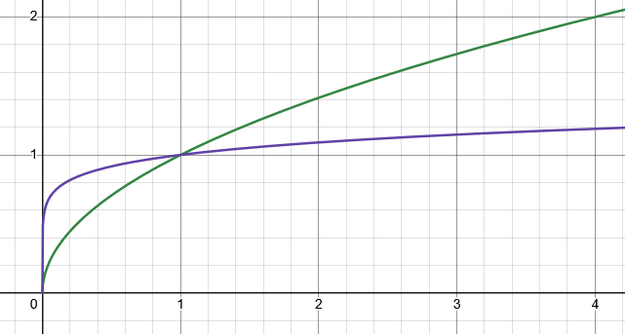
It might feel like, for a given x value, $\sqrt[8]{x}$ is “squishing” the value by more than $\sqrt{x}$ is, so it’s y-value should be smaller. For example: $\sqrt[8]{256}$ is 2, while $\sqrt{256}$ is 16. The eight root squished 256 all the way down to 2 while square root only squished it to 16.
Use an argument like the ideas in #7 to explain why $y=\sqrt{x}$ is below $y=\sqrt[8]{x}$ when $0<x<1$.
Families of Functions – Teaching Set 1 -- SOLUTIONS

1. [C] Fix the errors.
$$\sqrt{x}$$
$$\sqrt[3]{x}$$
$$x^{2}$$
$$x^{5}$$
Here’s what’s wrong:
- $x^{5}$ doesn’t have a “U” shape
- All the curves go through the point (1, 1)
- When $0<x<1$, $x^{2}$ is above $x^{5}$
- When $0<x<1$, $\sqrt{x}$ is below $\sqrt[3]{x}$

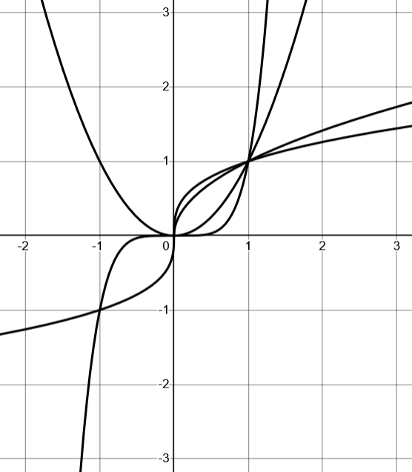
Here’s what it should look like:
All curves go through $(1, 1)$
$$x^{5}$$
$$x^{2}$$
$$\sqrt{x}$$
$$\sqrt[3]{x}$$


2. [C] When asked to sketch $y=2^{x}$ your partner produces this graph:
What are two specific reasons you could tell them that would convince them that this doesn’t make sense?
Their graph goes though (0, 0) but if you plug in x = 0 and y = 0 you get $0=2^{0}$ which isn’t true. Their graph has no points with negative x-values, but if you plug in $x=-1$ for example, you get $y=2^{-1}=\frac{1}{2}$ so there should be a point at $\left(-1,\frac{1}{2}\right)$

3. [C] Why does $y=x^{10}$ have a “U” shape, while $y=x^{7}$ doesn’t ?
If you plug-in a negative x-value, such as $x=-1$, $y=x^{10}$ will always have a positive y-value, since you’re multiplying the negative x-value by itself an even number of times. But $y=x^{7}$ will multiply the negative x-value by itself an odd number of times, so it will remain negative. The “U” shape occurs because $x^{10}={\left(-x\right)}^{10}$ . In other words, the y-value is the same for an x value and its opposite.

4. [C] Why is $y=x^{10}$ below $y=x^{3}$ when x is between 0 and 1?
Think about multiplying a number by itself over and over again. If the number is something like 2, it gets larger as it’s multiplied. However, a number between 0 and 1, like $\frac{1}{2}$ , gets smaller each time you multiply it by itself. For example: ${\left(\frac{1}{2}\right)}^{3}=\frac{1}{8}$ whereas ${\left(\frac{1}{2}\right)}^{10}=\frac{1}{1024}$ . So, for inputs between 0 and 1, $x^{10}$ will have a smaller value than $x^{3}$, which means the graph of $y=x^{10}$ will be below the graph of $y=x^{3}$ in that interval.

5. [C] Is the graph of $y=5^{x}$ ever below the graph of $y=3^{x}$? If not, explain why not. If so, explain where and why.
Yes, for all x < 0. Consider $x=-2$ for example. Plugging in we get $5^{-2}$ vs. $3^{-2}$. These equal $\frac{1}{5^{2}}$ and $\frac{1}{3^{2}}$ . Which of these is the smaller y-value? The one with the larger denominator, which came from ${y=5}^{x}$ . This same reasoning holds whenever x is negative.

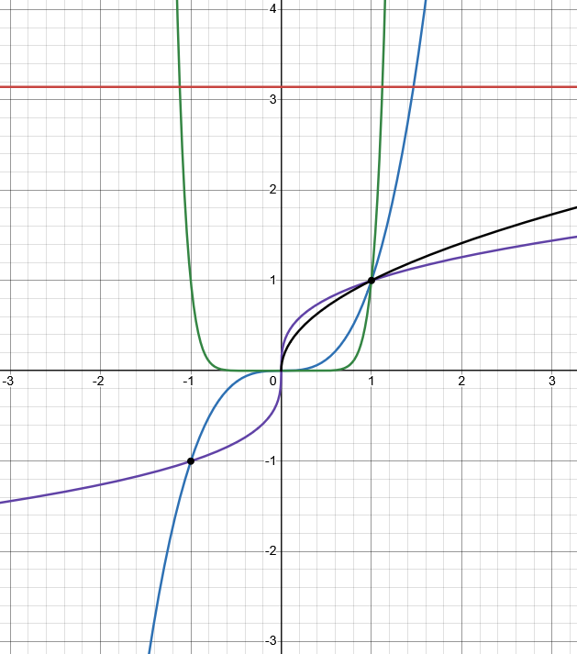
6. [P] On a single set of axes (similar to the one here), sketch all of the following curves.
a. $y=x^{3}$
b. $y=x^{10}$
c. $y=\sqrt[3]{x}$
d. $y=\sqrt{x}$
e. $y=π$

$π$ is just a number, so this is a constant function (horizontal line)

$y=\sqrt[3]{x}$ is defined for negative x values. Makes that “S” shape

Note $x^{10}$ is below $x^{3}$ when x is between 0 and 1, but above it when x > 1

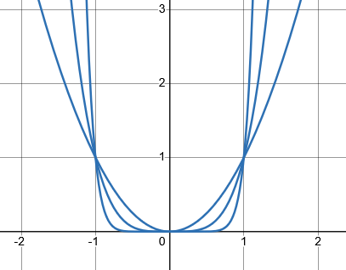
7. [C] Even powers $y=x^{2},y=x^{10},{y=x}^{22}$ etc. what is the same about all of the graphs? As the powers get larger, what changes?
The points $\left(-1,1\right), \left(0,0\right),$ and $(1,1)$ are all on the graph of every even power. What changes is that as the exponent gets larger the graph becomes a more exaggerated “U” shape.
In other words, between 0 and 1, the y-value stay close to 0 for longer before more steeply increasing. When $x>1$ the curve increases more steeply the larger the exponent.

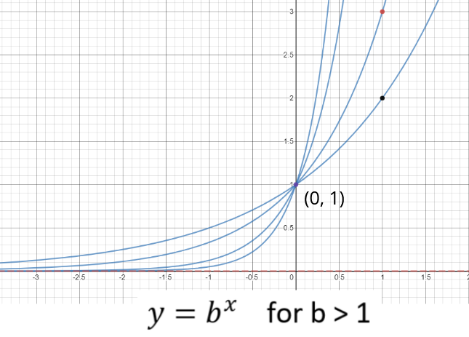
8. [C] For exponential functions $y=2^{x}$, $y=3^{x}$, $y={11}^{x}$ etc. What is the same about all of the graphs? As the base increases, what changes? There’s one point that’s the same for all the graphs. Why is it on every graph $y=b^{x}$ no matter what b is? (so long as $b>0$)
They all have the same overall shape, and they all go through the point $(0, 1)$.
The reason is because $b^{0}=1$ no matter what b is.
As the base increases the shape becomes more exaggerated. As x increases from 0, the function increases more steeply the larger the base. As x decreases from 0, the function approaches 0 more quickly the larger the base.

9. [P/C] On a single set of axes, sketch all of the following curves. Label points of intersection. Label each curve with its equation.
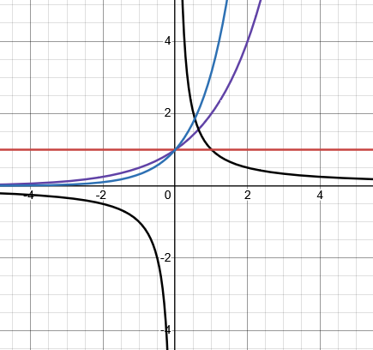
a. $y=2^{x}$
b. $y=\frac{1}{x}$
c. $y=1^{x}$
d. $y=π^{x}$

Since $π>2$, the curve $π^{x}$ is above $2^{x}$ when x > 0
$1^{x}$ is always 1, so this is a horizontal line.

10. [C] For even powers, the “U” shape becomes more “square” as the exponent gets larger. Why?
When $0<x<1$, multiplying x by itself “squishes” the number toward zero, whereas when $x>1$ it “stretches” it away from 0. At x = 1, $x^{even power}$ always equals 1.
The amount of the “squishing” and “stretching” is greater the more times x is multiplied by itself. That means that higher powers of x produce a more exaggerated U shape.

11. [C] What’s a good explanation for why you can’t take the square root of a negative, such as, $\sqrt{-8}$ (and get a real number as an answer), but you can get a real valued answer equal to $\sqrt[3]{-8}$ ?
a). Here’s one way of explaining carefully why $\sqrt{-4}$ isn’t a real number.
Say $\sqrt{-4}=M$ for mystery. What do we know about M ? If we square it, it should give us $-4$: $M^{2}=-4$ .
So, M is a number that gives -4 when you square it. But there is no real number that does that, since squaring a (real) value always results in a positive number (or 0 if you square 0). That means $M=\sqrt{-4}$ can’t be a real number.
b). Use the idea to explain why $\sqrt[3]{-8}$ is a real number.
Let’s use the same style of reasoning. Say $\sqrt[3]{-8}=M$ for mystery. Here we could cube both sides to get $-8=M^{3}$ . So, M is a number that gives -8 when you cube it. There’s no problem with that, though, because if M were a negative number, cubing it would result in a negative number. So it should be possible. In this case if $M=-2$ cubing it gives -8. Therefore $\sqrt[3]{-8}=-2$.

12. [C] This graph illustrates that $y=\sqrt{x}$ is below $y=\sqrt[8]{x}$ when $0<x<1$

It might seem like $\sqrt[8]{x}$ is “squishing” the x values by more than $\sqrt{x}$ is, so the y-values should always be smaller.
Use an argument like the ideas in #7 to explain why $y=\sqrt{x}$ is below $y=\sqrt[8]{x}$ when $0<x<1$.

Let’s illustrate with $x=\frac{1}{2}$ . Which y-value is larger: $\sqrt{\frac{1}{2}}$ or $\sqrt[8]{\frac{1}{2}}$ ? Maybe it’s not too clear.
Let’s give them names: $\sqrt{\frac{1}{2}}=A$ and $\sqrt[8]{\frac{1}{2}}=B$
So: $\frac{1}{2}=A^{2}$ and $\frac{1}{2}=B^{8}$
What do we know about A and B? They have to be less than 1. If they were larger than one, multiplying them by themselves would only make them continue to get larger. Since A and B are less than one, the larger the exponent, the smaller they must become. Raising something (between 0 and 1) to the 8th power shrinks it by a lot more than raising it to the 2nd power. But we know that $B^{8}$ and $A^{2}$ both end up at $\frac{1}{2}$. Therefore B must have started out larger for it to have shrunk by more but ended at the same place.
An easier to think about argument will be available to us once we review inverses. Then we can say that $y=\sqrt{x}$ is below $y=\sqrt[8]{x}$ when $0<x<1$, because $y=x^{2}$ is above $y=x^{8}$ when $0<x<1$. We’ll do this again a in few problem sets.

